[Picasso’s Art] Site Plan

[Grace Rawlings]

WDD 130

Overview

Purpose
[To teach interested people about some of Picasso’s famous art.]

Audience
[People curious about art.]

Branding

Website Logo


Style Guide

Color Palette
Primary | Secondary | Accent 1 | Accent 2
#802392 | #246A73 | 995FA3 | #A5F8D3

Typography

Heading Font: [Lobster Two]

Paragraph Font: [Bitter]

Navigation
Picasso Guernica The Old Guitarist

Content

Pablo Picasso
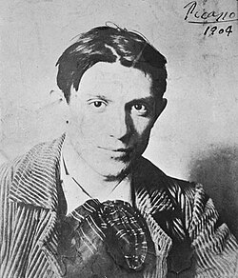

Pablo Picasso was a Spanish painter, sculptor, printmaker, ceramicist, and stage designer. He is widely considered one of the most influential artists of the 20th century. Throughout his long career, Picasso constantly experimented with new artistic styles and ideas, helping reshape the direction of modern art.

Picasso is especially known for helping develop Cubism, a revolutionary style of art that changed how objects and people were represented in paintings. Instead of painting subjects realistically from a single viewpoint, Cubism broke them into geometric shapes and showed them from multiple perspectives at once.

Early Life

Picasso was born on October 25, 1881 in Málaga. His father, José Ruiz y Blasco, was an art teacher and painter who recognized his son’s artistic talent at an early age.

Picasso began drawing and painting when he was very young, and he quickly showed extraordinary skill. According to stories about his childhood, Picasso was already producing advanced artwork by the time he was a teenager.

As a young artist, he studied at art schools in Spain and later moved to Paris, which was one of the most important centers for art in the early 1900s. Living in Paris exposed Picasso to many different artists and new artistic ideas that influenced his work.

Picasso’s Artistic Style

One of the most unique aspects of Picasso’s career was his constant willingness to experiment. Rather than sticking with a single style, he explored many different techniques and approaches throughout his life.

Picasso created artwork using many different forms, including:

Painting

Sculpture

Printmaking

Ceramics

Stage design for theater and ballet

Over the course of his lifetime, Picasso produced tens of thousands of artworks, including paintings, drawings, sculptures, and prints.

Major Artistic Periods

Art historians often divide Picasso’s work into several major periods based on the style and themes of his paintings.

Blue Period (1901–1904)

During the Blue Period, Picasso created paintings dominated by cool blue and gray tones. These works often focused on themes of sadness, poverty, loneliness, and human suffering.

Many paintings from this time show people on the margins of society, such as beggars, prisoners, and the elderly.

One of the most famous works from this period is The Old Guitarist, which shows a frail, blind musician holding a guitar.

Rose Period (1904–1906)

Following the Blue Period, Picasso’s work shifted to warmer colors such as pinks, reds, and oranges. This time is known as the Rose Period.

During this period, Picasso often painted circus performers, acrobats, and entertainers. The mood of these paintings was generally lighter than his earlier works.

African-Influenced Period (1907–1909)

Around 1907, Picasso became interested in African sculptures and masks. These artworks inspired him to simplify human figures into more abstract shapes and forms.

This experimentation led directly to the development of Cubism.

Cubism (1909–1919)

Picasso helped develop Cubism along with the French artist Georges Braque.

Cubist paintings break objects into geometric shapes and show them from several viewpoints at the same time. This style challenged traditional ideas about perspective and realism in art.

Cubism became one of the most influential movements in modern art and inspired many artists around the world.

Picasso and War

Some of Picasso’s most powerful works were inspired by political events and war. During the Spanish Civil War, Picasso created one of his most famous paintings, Guernica.

This massive black-and-white mural was painted in response to the bombing of the town of Guernica. The painting shows the suffering of people and animals during war and has become a powerful symbol of protest against violence.

Picasso’s Legacy

Pablo Picasso lived a long life and continued creating art into his later years. He died on April 8, 1973 in Mougins.

Today, Picasso is remembered as one of the most important and influential artists in history. His willingness to experiment with style and technique helped push art in new directions and inspired generations of artists.

Many of his works are displayed in museums around the world, and his paintings are among the most famous and valuable ever created.

Guernica
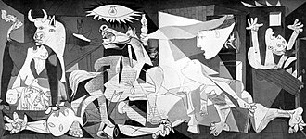

Guernica is one of the most famous anti-war paintings in history. Pablo Picasso created the painting in 1937 during the Spanish Civil War after the bombing of the Spanish town of Guernica.

The attack on Guernica occurred on April 26, 1937, when German and Italian warplanes supporting Spanish nationalist forces bombed the town. The bombing destroyed much of the town and killed many civilians. News of the tragedy quickly spread across Europe, and Picasso was deeply affected by the event.

Why Picasso Painted It

At the time, Picasso had been commissioned by the Spanish government to create a large mural for the Spanish Pavilion at the 1937 Paris International Exposition in Paris. After hearing about the bombing, he decided to dedicate the mural to the tragedy in Guernica.

Rather than painting a literal depiction of the bombing, Picasso created a symbolic and emotional scene that communicates the horror and chaos of war.

What the Painting Shows

The painting is large—over 11 feet tall and 25 feet wide—and filled with dramatic figures. Instead of using color, Picasso chose a palette of black, white, and gray. This gives the painting a stark and somber mood, similar to a newspaper photograph.

Several powerful images appear in the artwork:

A screaming mother holding her dead child

A horse in the center of the painting, appearing wounded and distressed

A bull, which some interpret as representing brutality or Spain itself

A fallen soldier with a broken sword

Figures crying out in pain and panic

The distorted shapes and fragmented forms reflect the influence of Cubism, a style Picasso helped develop.

Meaning and Interpretation

Many historians and critics believe that Guernica represents the suffering of innocent civilians during war. The broken figures and chaotic composition create a sense of confusion and terror.

Although Picasso never gave a single official explanation for every symbol in the painting, he made it clear that the work was meant to condemn violence and brutality.

Over time, the painting has become a universal symbol of protest against war and injustice.

Where the Painting Is Today

After it was first displayed in Paris, Guernica traveled to several countries to raise awareness about the Spanish Civil War. For many years it was kept at the Museum of Modern Art in New York City.

In 1981, the painting was finally returned to Spain. Today it is displayed at the Museo Reina Sofía in Madrid, where it remains one of the most visited artworks in the country.

The Old Guitarist
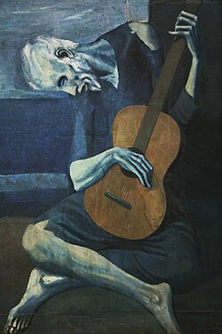

The Old Guitarist is one of the most well-known paintings from the early career of Pablo Picasso. The painting was created in 1903 during a time in Picasso’s life known as the Blue Period, when many of his artworks were dominated by blue tones and somber themes.

This painting portrays an elderly, blind musician sitting on the ground while holding a guitar. The figure appears thin and fragile, and his body is bent over the instrument.

Picasso’s Blue Period

Picasso’s Blue Period lasted roughly from 1901 to 1904. During these years, he often painted scenes of poverty, loneliness, and suffering.

The period was partly influenced by the death of Picasso’s close friend, Carlos Casagemas. After this tragedy, many of Picasso’s works became darker and more emotional.

Paintings from this time often show people who were struggling in society, such as beggars, prisoners, and the elderly.

Description of the Painting

In The Old Guitarist, most of the image is painted in shades of blue and gray. This cool color palette creates a feeling of sadness and isolation.

The musician’s body is elongated and almost skeletal, emphasizing his age and hardship. His eyes appear closed or blind, suggesting that he may be disconnected from the world around him.

One of the most striking features of the painting is the brown guitar, which stands out against the blue background. The warm color draws attention to the instrument, suggesting that music may be the only comfort or source of meaning in the man’s life.

Hidden Details

Modern technology has revealed that Picasso painted over other images while creating The Old Guitarist. Using infrared imaging and X-ray analysis, researchers discovered that earlier sketches of other figures were hidden beneath the final painting.

This was not unusual for Picasso at the time, since he often reused canvases because he could not always afford new materials.
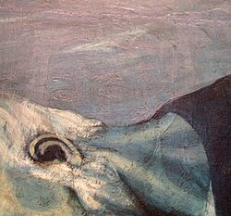

Where the Painting Is Today

Today, The Old Guitarist is part of the permanent collection at the Art Institute of Chicago in Chicago.

It remains one of the most recognized examples of Picasso’s Blue Period and continues to be studied for its emotional depth and artistic style.

Wireframes
